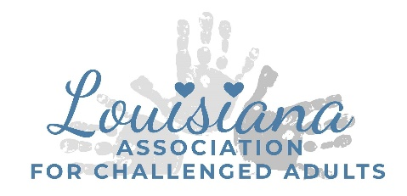
Clean Up Rules and Procedures
- All Trash must be removed from the buildings and outside garbage cans and placed in the dumpster at the front of the property.
- All renters must have all of their personal items and decorations removed by the end of the event. Renters will not be allowed back an extra day to clean and pack up.
- Please leave all linens in place so that our cleaning crew can properly treat the stains.
- Any damage made to LAC building will be an additional upcharge that will be charged to you after the event. Remember, your guests are your responsibility…send you invitations wisely.
- Please remove any food from LAC fridge and Kitchen area
- Please clean up any liquid spills before leaving the building as it stains the flooring.

I have read and understand the clean up rules and procedures required of me and I understand that failure to comply with the clean up rules and procedures may result in an upcharge.

Renter Signature:___________________________ Date:______________

